# Client Specifications

We have a fictitious client who wants to have a gardening shop. He will need the following:

* At least four (4) web pages
* The landing page will need to have a carousel.
* The website is to be responsive with Mobile first design.
* You will need a contact form.
  + This form will need to have some indication (maybe a dropdown) of what the customer is interested in. A list of categories is provided below.
* Two videos from YouTube (copyright and use is assumed). If you don’t have access to two videos for this exercise, I can provide you with them.
* A gallery of twenty (20) products promoting the distinct parts of the Gardening Shop. I would suggest you “borrow” these from the internet for this exercise (please take note of where you found the images, in case we need to ask permission to use these images in the future – copyright issues).
* Colours and layout will be up to you. There will need to be a “green organic garden” feel to the theme.

The garden shop sells the following items:

* Plants – fragrant, fruits, herbs, ground covers, natives, indoor, hedges, potted, roses and bulbs.
* Pots
* Gifts
* Garden tools
* Fertilisers

# Site Map

# Website Style

## Logo Design

Logo is based of a monstera plant.

|  |
| --- |
| Logo |
|  |
| Client Feedback |
|  |
| Approved? |
| Y/N |

## Style Tyle

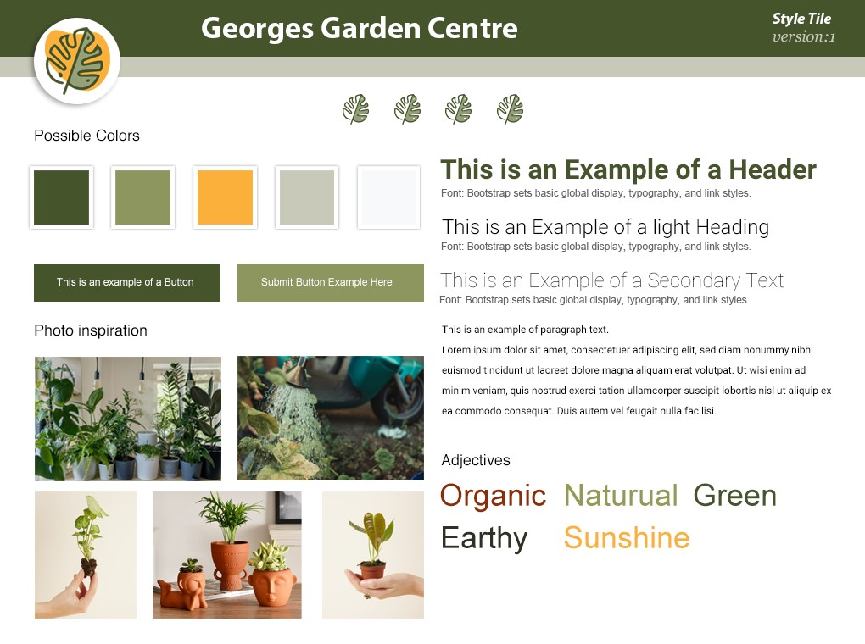

|  |
| --- |
| Client Feedback |
|  |
| Approved? |
| Y/N |

# Wireframes

## Home page (mobile view)

|  |  |
| --- | --- |
|  |  |

|  |
| --- |
| Client Feedback |
|  |
| Approved? |
| Y/N |

## Product Page (mobile view)

|  |
| --- |
| This will be a product gallery of bootstrap cards. |

|  |
| --- |
| Client Feedback |
|  |
| Approved? |
| Y/N |

## About US Page (mobile view)

|  |
| --- |
|  |

|  |
| --- |
| Client Feedback |
|  |
| Approved? |
| Y/N |

## Videos Page (mobile view)

|  |
| --- |
|  |

|  |
| --- |
| Client Feedback |
|  |
| Approved? |
| Y/N |

## Contact Form (mobile view)

|  |
| --- |
|  |

|  |
| --- |
| Client Feedback |
|  |
| Approved? |
| Y/N |